# CHAPTER 5

**SCREEN SHOTS**

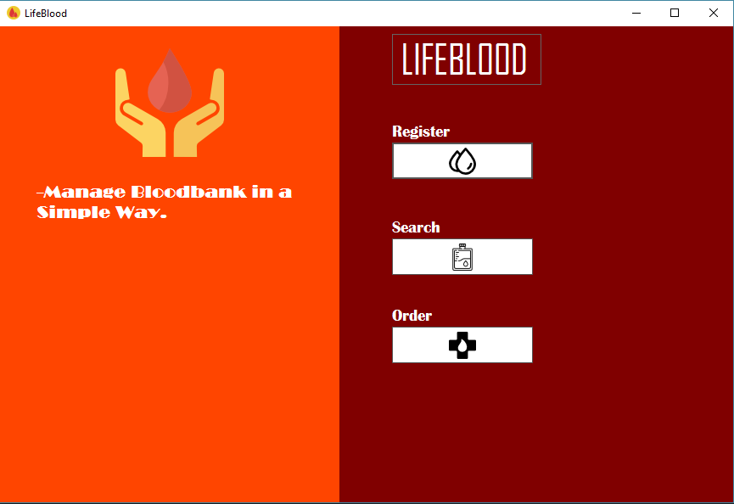

Figure5.1 Starting page of Blood bank management system

The Starting page the software allows performing of three operations. The Operations are Register, search, order.

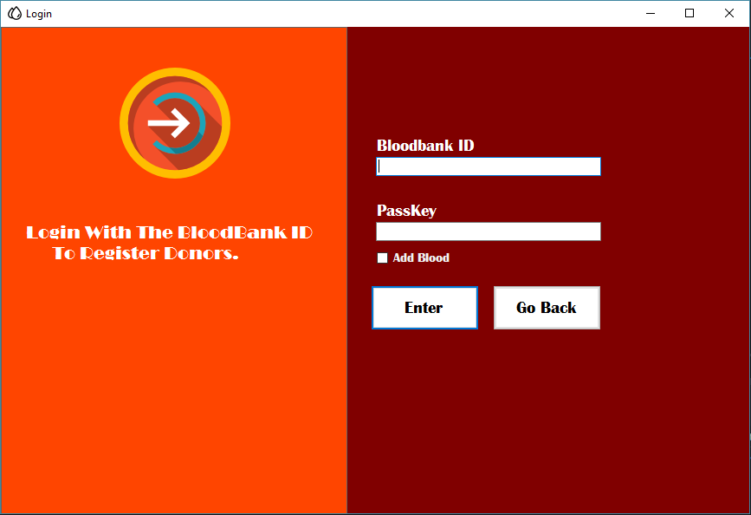

Figure 5.2 receptionist Login using Blood bank ID

In this page receptionist can be login using the Bloodbank Id and PassKey. The Boodbank ID and PassKey provided by the Developers

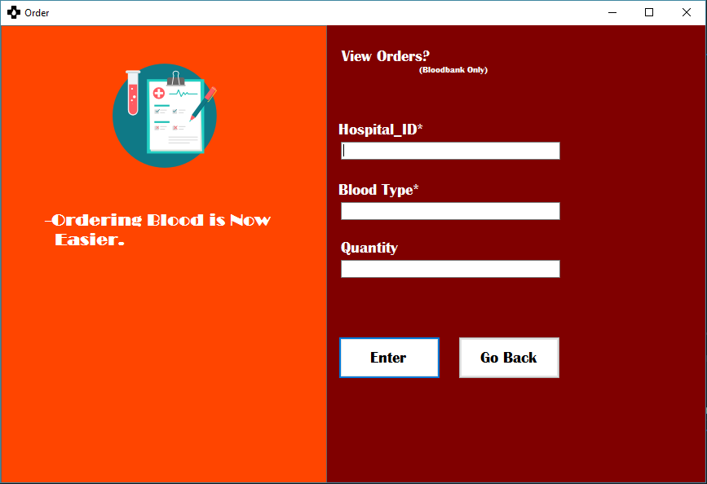

Figure 5.3 Hospitals Orders Blood.

In this page the hospitals can order blood by using the hospital id provided by the developers and the blood bank can also view the orders placed by the hospitals.

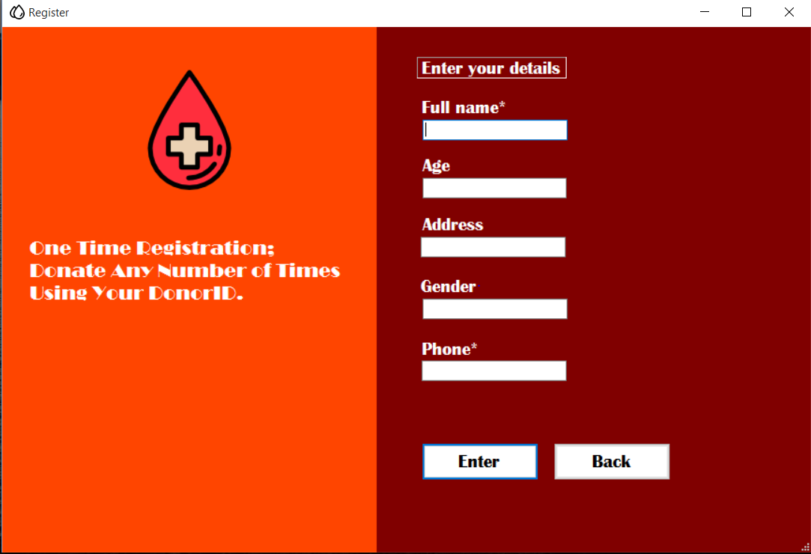

Figure 5.4 New user registration.

In this page receptionist can register new user after adding a new user, a donor id is generated which is used by the donor to donate blood next time.